Reflection Report

Practice Module for Certificate in Designing Modern Software Systems

Team <Number 6>
Name: <Ding Zuhao>

CONTENTS
1. Reflection 3
1.1 Process 3
1.2 Architecture and Design 3
1.3 Development and Implementation 4
1.4 Lesson Learnt 4
1.5 Innovation 4
1.6 Value 5
2. Learning Report 6
2.1 Foundational Learning 6
2.2 Backend Architecture 7
2.3 Security & Authentication 9
2.4 DevOps Practices 10
2.5 Frontend Awareness 10
2.6 Class diagrams 13
2.7 Core use case Sequence diagrams 14
3. conclusion 16

Reflection
Provide your personal reflection of the project that you have completed. A reflection is basically an essay describing your personal opinion on your learning and experience through this project. Although an essay would not have sub-sections, you can use the sections below to guide you in your reflection but if you prefer you may come up with your own sub-sections to organize your reflection or use no sub-sections at all.
This practice module has been one of the most challenging yet transformative learning experiences in my academic journey. Entering the project as a beginner in Java, Spring Boot, and modern full-stack development, I was faced with a steep learning curve. However, through continuous effort, self-directed learning, and hands-on practice, I gradually built up the ability to contribute meaningfully to the system and gained a much deeper understanding of modern software engineering practices.

Process
Describe your thoughts about how your project was conducted.
At the beginning of the project, I struggled significantly due to my lack of Java development experience. Although our team lead had already prepared a project skeleton on the development branch, I mistakenly pulled the code from the main branch and attempted to start from scratch. Without understanding Spring Boot’s project structure, annotations, or the layered architecture, I often felt lost and hesitant to make changes. This caused a large amount of unnecessary time being spent on rebuilding foundations I had not yet mastered.
Database and API design also posed major difficulties. With little prior experience in front-end/back-end separation and minimal exposure to practical networking concepts, I had trouble understanding how data flowed between services. I therefore spent a considerable amount of time补ing theoretical gaps, such as HTTP communication, RESTful conventions, and database schema design.
During coding, I frequently encountered issues such as JDK version mismatch, missing Maven rebuilds, annotation misunderstandings, module configuration errors, and other Spring Boot-specific conventions. My lack of effective debugging habits and unfamiliarity with using AI tools for productivity slowed me down considerably, resulting in delays during early sprints. Some tasks had to be backed up by teammates, especially Haotian, which made me more aware of my shortcomings but also motivated me to improve.
Communication also became a personal challenge. I tended to report only to the team lead instead of maintaining active communication with the whole team. Combined with cultural and language factors, misunderstandings accumulated, and I later realized that some teammates had concerns about my progress. I tried to clarify, but communication channels had already deteriorated. This experience taught me the importance of proactive and transparent team collaboration.
Despite these obstacles, my efficiency improved significantly in the later stages. I managed to complete the major functions of the user module, implement performance tests using JMeter, debug and fix CI pipeline issues, and even learn from Haotian’s code style to improve my own. I also explored enhancements to the Gomoku AI logic, gaining experience in both backend engineering and algorithmic thinking.
Through all these struggles, I overcame the initial barrier of entering the field and formed my own learning methodology. This project not only strengthened my technical foundation but also significantly improved my resilience, adaptability, and self-reflection ability.

Architecture and Design
Describe your thoughts about the design process and design deliverables of your project or opinion on how the design was formulated.
Our project adopted a modern distributed architecture with clear separation of concerns. The backend followed a layered design—controller, service, mapper, entity, and utility classes—while the frontend used React with TypeScript and service-based API calls. Understanding these design principles was initially difficult for me, but as the project progressed, I gradually appreciated why modularity, reusability, and clean architecture were essential in large-scale software systems.
I also learned to use UML diagrams to plan flows, clarify user stories, and design backend logic, which greatly improved my understanding and ability to reason about system structure.

Development and Implementation
Describe your thoughts on the process and deliverables of the development and implementation of your project.
Implementing the user module required me to handle Java 17, Spring Boot 3.2, MyBatis, JWT authentication, Redis token caching, RSA encryption, and BCrypt hashing. These were completely new to me. By repeatedly reading documentation, debugging small prototypes, testing endpoints with Postman, and studying team code, I gradually built confidence and fluency.
I also completed JMeter performance tests and integrated them into CI, which strengthened my understanding of DevOps workflows, pipelines, and automated reporting.

Lesson Learnt
Describe what you’ve learnt from this project in both technical and non-technical aspect of things. Reflect on what you would have done differently if you were to redo the project.
- Learning depends on personal initiative; asking peers with similar learning curves is often more effective.
- New technologies should not be feared—familiarity comes through hands-on practice.
- Building a personal learning system is essential: understand concepts → practice → debug → reflect.
- Security matters: token handling in front-end headers must never be overlooked.
- Early and transparent communication prevents misunderstandings.
- Emotional resilience is crucial in team projects.
- Balancing personal stress and academic commitments is essential for sustained performance.

Innovation
Describe the innovative processes/technology/tools/practices you think were used during this project.
1. Layered password security (RSA + BCrypt)
RSA asymmetric encryption for password transmission to protect against interception.
BCrypt hashing with per-user salts for storage to resist rainbow tables and brute-force attacks.
This two-stage approach secures both transmission and storage.
2. Per-user JWT signing with refresh token
Uses a user-specific refresh token as JWT signing key material.
Enables token revocation at the user level without affecting other users.
A revocation record in the database ensures tokens remain invalid even before expiration.
3. Dual-storage fallback for verification codes
Primary: Redis for distributed caching and automatic expiration.
Fallback: In-memory storage with scheduled cleanup if Redis is unavailable.
Provides reliability during Redis outages or misconfigurations.
4. Microservices-ready architecture
Separation of concerns: Controller → Service → Mapper layered design.
RESTful APIs with standardized response formats (ApiResult).
Independent deployability as a standalone module.
API versioning support via /api/user prefix.
5. Centralized exception handling
Global exception handler (@RestControllerAdvice) unifies error responses.
Business exceptions (BusinessException) separate business logic errors from system errors.
Standardized HTTP status codes and error messages for clients.
6. Development/Production mode switching
Configurable email sending (app.mail.verify-switch-off) for development.
In development, codes are logged; in production, emails are sent via QQ SMTP.
Reduces external dependencies during development and testing.
7. CI/CD integration
GitLab CI/CD workflows for automated testing and deployment.
Automated build verification.
Supports continuous integration practices.
8. API documentation automation
Swagger/OpenAPI integration for interactive documentation.
Annotations (@Tag, @Operation) keep documentation synchronized with code.
Improves developer experience and onboarding.

Value
Describe the value that you think was delivered by this project to your potential customers.
- Maintainability
Layered architecture eases understanding and modification. Global exception handling reduces boilerplate. Comprehensive logging aids debugging.
- Scalability
Microservices design allows independent scaling. Stateless design supports horizontal scaling. Redis caching improves throughput.
- Documentation
Swagger/OpenAPI provides interactive documentation. Code comments and structured logging aid understanding. Clear project structure.
- Development efficiency
Mode switching speeds development. CI/CD automates testing and deployment. Standardized patterns reduce decision overhead.
- Cost-effectiveness
Open-source technology stack. Spring Boot, MySQL, Redis, Docker. Low licensing costs. Active community support.
- Efficient architecture
Microservices enable independent scaling and reduce resource waste. Caching reduces database load. Stateless design simplifies infrastructure.
- Reduced maintenance costs
Centralized exception handling reduces bug-fixing time. Automated testing catches issues early. Clear documentation reduces onboarding time.
Could the same value be delivered with less cost/effort?
In short term, simplifications could reduce initial effort, but at the cost of security, scalability, and maintainability. But in long term, the current approach reduces technical debt and maintenance costs, delivering better value over time.
Conclusion: The current architecture balances security, performance, scalability, and maintainability. While initial implementation effort is higher, the long-term benefits outweigh the costs, especially as the system scales and evolves.

Learning Report
Due to my relatively weak foundational background and the fact that this module was my first experience working on a Java-based project, the quality, usability, and timeliness of my early code contributions were limited. As a result, many of my efforts and learning outcomes were not fully reflected in the final project deliverables. I sincerely apologize for any inconvenience this may have caused to the teaching team or my project group.
Out of respect for the professors’ evaluation process, and in order to more accurately present the substantial learning progress I have achieved despite these initial challenges, I have prepared this supplementary learning report. Its purpose is to provide a clearer and more comprehensive account of the technical knowledge, skills, and personal growth I have gained throughout the module.
Throughout this module, I gradually formed a structured learning methodology. Furthermore, the user module was implemented, and the front-end was completed using AI. The front-end and back-end were connected and the system ran smoothly. The code is as follows: https://github.com/nussejzz/GoMoku
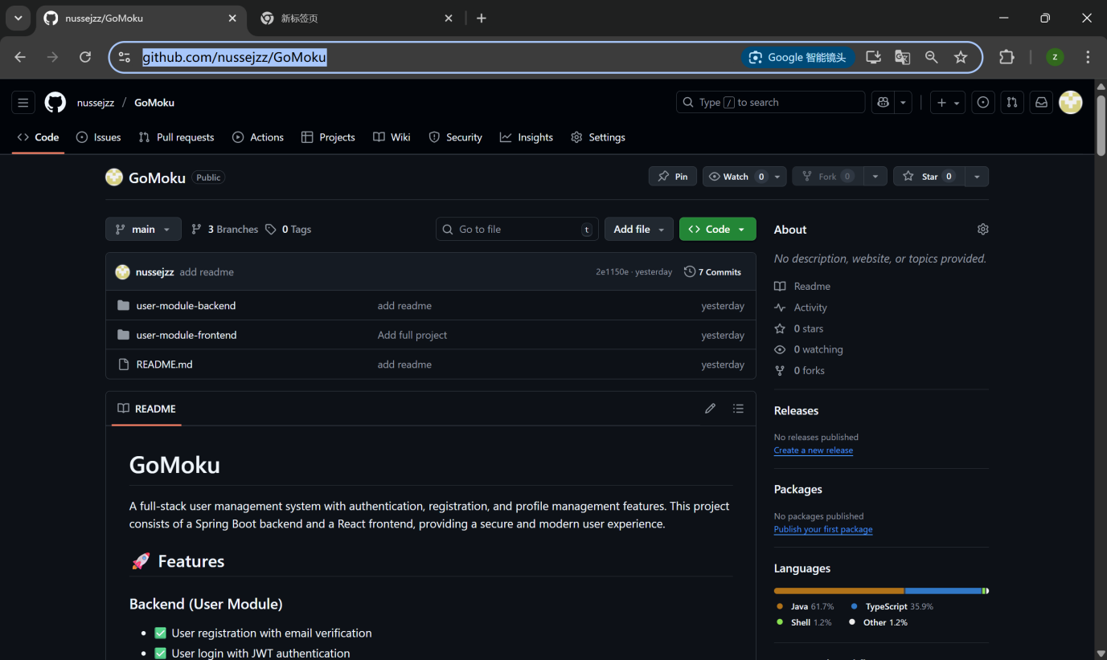

Foundational Learning
I started by understanding Java syntax, OOP principles, Maven dependencies, and basic Spring Boot architecture.
Part of my learning of JavaSE: https://github.com/nussejzz/foundation/tree/main/JavaSE
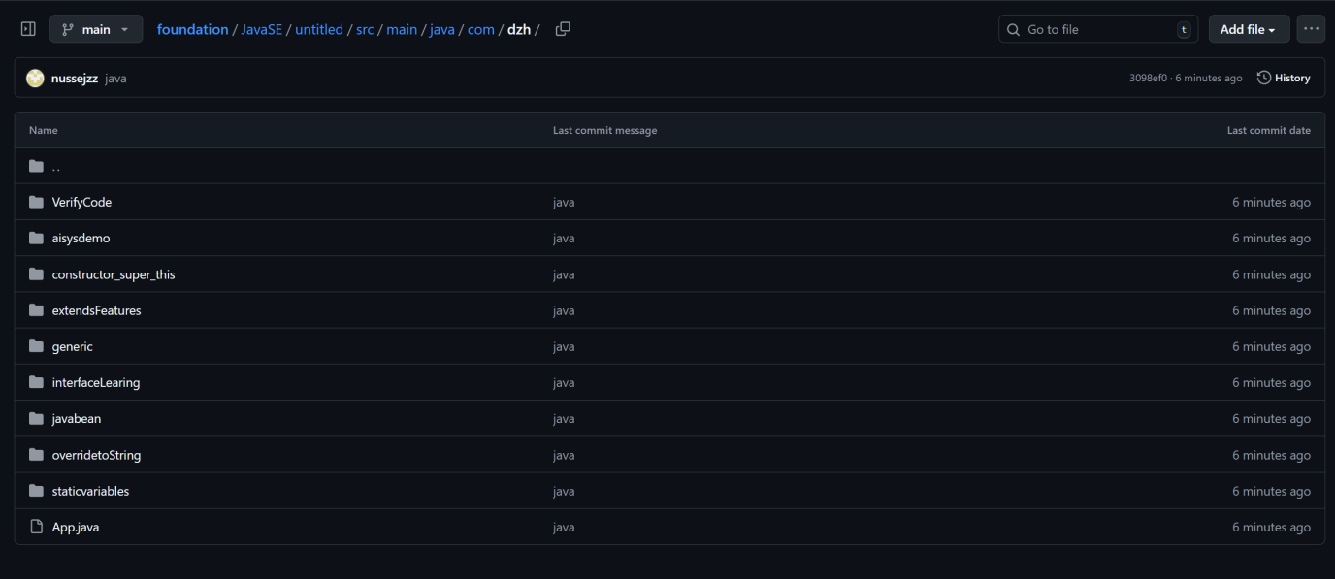
Part of my learning of JavaWeb: https://github.com/nussejzz/foundation/tree/main/JavaWeb
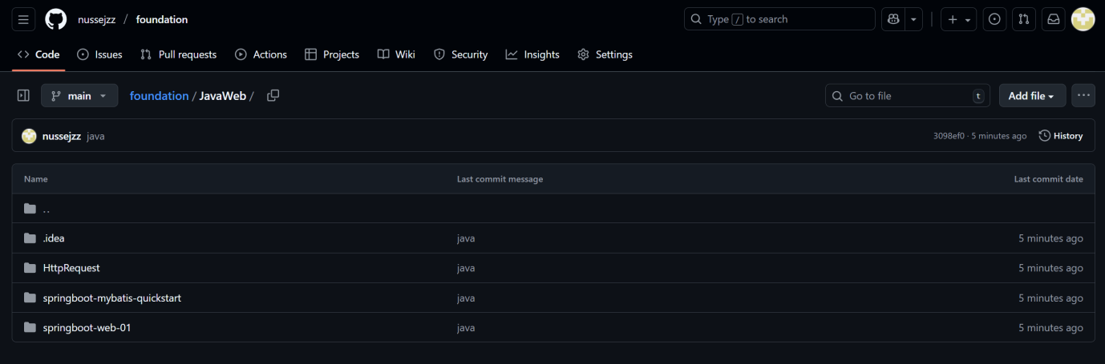

Backend Architecture
I studied the layered structure (controller, service, mapper), MyBatis usage, DTO/VO design, and exception handling patterns.

Layered Architecture
- Controller Layer
UserLoginController handles authentication processes including registration, login, logout, token verification, and password reset.
UserInfoController handles user profile retrieval.
EmailController manages the sending of email verification codes.
Responsibilities include receiving HTTP requests, validating input parameters, invoking the corresponding service methods, and returning standardized API responses (ApiResult).
The controller layer uses annotations such as @RestController, @RequestMapping, and Swagger annotations (@Tag, @Operation).
- Service Layer
UserLoginService contains the core authentication logic.
UserService encapsulates user-related operations.
UserTokenService manages refresh tokens and token lifecycle.
EmailService handles email delivery and verification code management.
UserInfoService processes user information queries.
Responsibilities include implementing business logic, managing transactions through @Transactional, and handling domain-specific exceptions using BusinessException.
- Mapper Layer
UserMapper provides data access for user accounts.
UserTokenMapper provides data access for token storage.
These components use MyBatis interfaces with SQL defined in XML mapping files.
Responsibilities include abstracting database operations and centralizing SQL management.
- Entity Layer
User represents the user account entity.
UserToken represents the token storage entity.
Responsibilities include modeling the database structure and mapping table fields to Java objects.
- VO Layer
Request objects include UserRegisterRequest, UserLoginRequest, and UserResetPasswordRequest.
Response objects include UserLoginResponse, UserRegisterResponse, UserVerifyResponse, and ApiResult.
Responsibilities include representing data transfer objects (DTO/VO) and defining the data contract between the frontend and backend.

Microservice Modular Design
The backend module is developed as a standalone microservice:
Independent deployment: The user-module can be deployed and scaled individually.
Versioned API: Unified API prefix "/api/user" for all endpoints.
Service naming: user-module.
Context path: context-path = /api/user.
Dependency injection: Constructor-based injection using @RequiredArgsConstructor.
Externalized configuration: All settings stored in application.yaml.

Database Design
Link: https://github.com/nussejzz/GoMoku/blob/main/user-module-backend/src/main/resources/init.sql
- Connection Pool (HikariCP):
minimum-idle = 1.
maximum-pool-size = 10.
These settings reduce connection creation overhead and improve performance.
- Table Structure:
user: Main table with unique constraints on email and nickname.
user_token: Stores refresh tokens for JWT validation and revocation.
- MyBatis Configuration:
Automatic underscore-to-camelCase mapping.
SQL managed through XML mapping files.
Support for dynamic and complex SQL queries.

Caching Architecture
Redis is used as the primary caching solution:
Redis as main cache (verification code storage).
In-memory fallback if Redis becomes unavailable.
TTL-based expiration (5-minute validity for verification codes).
Dual-layer caching improves reliability and availability.

Utility Layer
Key utility classes include:
RsaCryptoUtil: RSA key generation, encryption, and caching
JwtTokenUtil: JWT creation, parsing, signature validation
PasswordHashUtil: BCrypt hashing and password validation
GenerateRsaKeys: RSA key generation helper

Security & Authentication
I learned RSA, BCrypt, JWT, token refresh mechanisms, and how secure login systems work in real-world applications.

Password Transmission Security — RSA Encryption
Mechanism:
Frontend retrieves the RSA public key from the endpoint /api/user/public-key.
Frontend encrypts the password using the public key.
Backend decrypts the encrypted password using the private key through RsaCryptoUtil.decryptWith().
The private key is stored securely on the server.
Security Features:
Prevents plaintext password interception during transmission.
Uses double-checked locking and the volatile keyword for secure key caching.
Passwords are transmitted using Base64-encoded encrypted data to avoid exposure.

Password Storage Security — BCrypt Hashing
Mechanism:
Each user password is combined with a unique salt generated through UUID.
A one-way hash is computed using PasswordHashUtil.hashPassword().
The resulting 60-character BCrypt hash is stored in the database.
Security Benefits:
Provides strong resistance against rainbow table attacks due to unique salts.
The hashing cost factor can be adjusted to strengthen security.
Password verification is performed using verifyPassword() without ever exposing plaintext credentials.

Identity Authentication — JWT Token System
JWT contains userId, email, nickname, refreshToken and expiration. Tokens are configured with a 24-hour expiration time (86400000 ms).
Innovative Signing Strategy:
The refresh token is used as the signing key material for JWT generation.
Each user therefore has a unique signing key. This design enables user-specific JWT revocation.
Verification Flow: Extract the userId from the JWT→Retrieve the corresponding refresh token from the database→Recompute the signing key from the refresh token→Validate the JWT signature and expiration time→Return the user identity information or mark the token as invalid.

Refresh Token Mechanism
Storage and Lifecycle: Refresh tokens are stored in the user_token table→Each token is generated through UUID→Tokens remain valid for 7 days.
Revocation Cases:Users logging out, Users performing a password reset.
Any signing mismatch automatically invalidates old tokens.

Email Verification Security
Redundant Storage Model:
Redis is used as the primary storage for verification codes.
An in-memory fallback is used if Redis is unavailable.
Security Controls:
Verification codes expire automatically after 5 minutes.
Codes are deleted immediately after successful verification.
The mechanism prevents replay attacks and malicious repeated registration attempts.

DevOps Practices
By working with Docker, GitLab CI/CD, and JMeter performance testing, I gained practical insights into automation and system deployment.

Frontend Awareness
While not the main contributor to the frontend, reading React + TypeScript code helped me understand front-end/back-end integration. Now I can complete the simple frontend with ai tools on my own, like what I do in this project: https://github.com/nussejzz/GoMoku/tree/main/user-module-frontend

Registration page
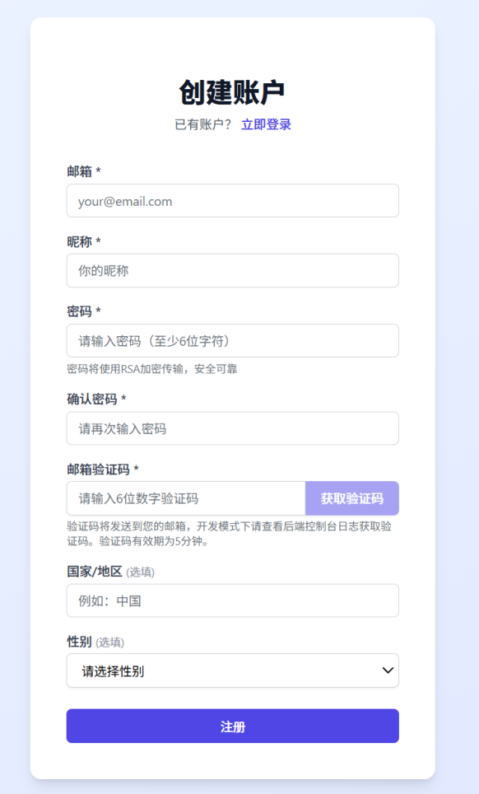

User Info page
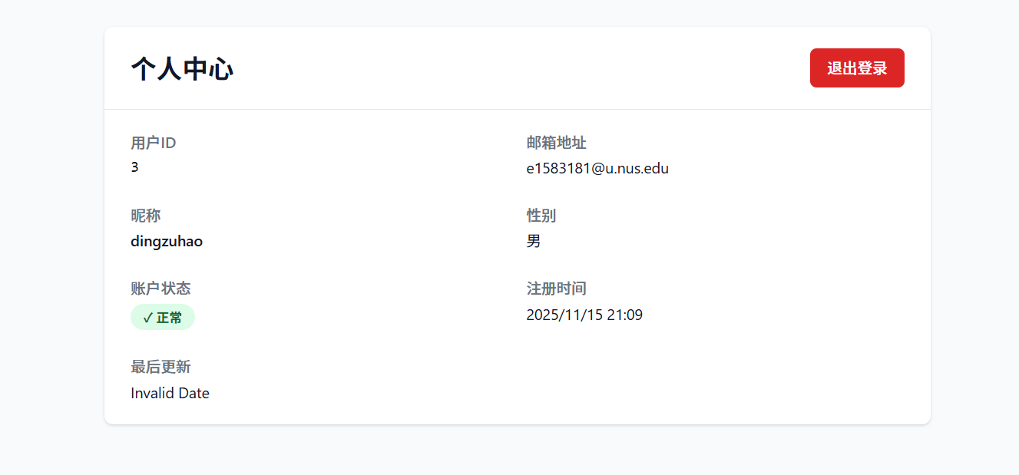

Registration page
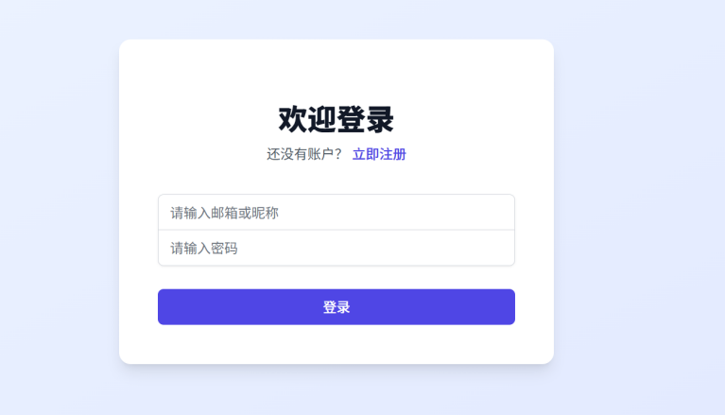

The user received a verification code.



Class diagrams
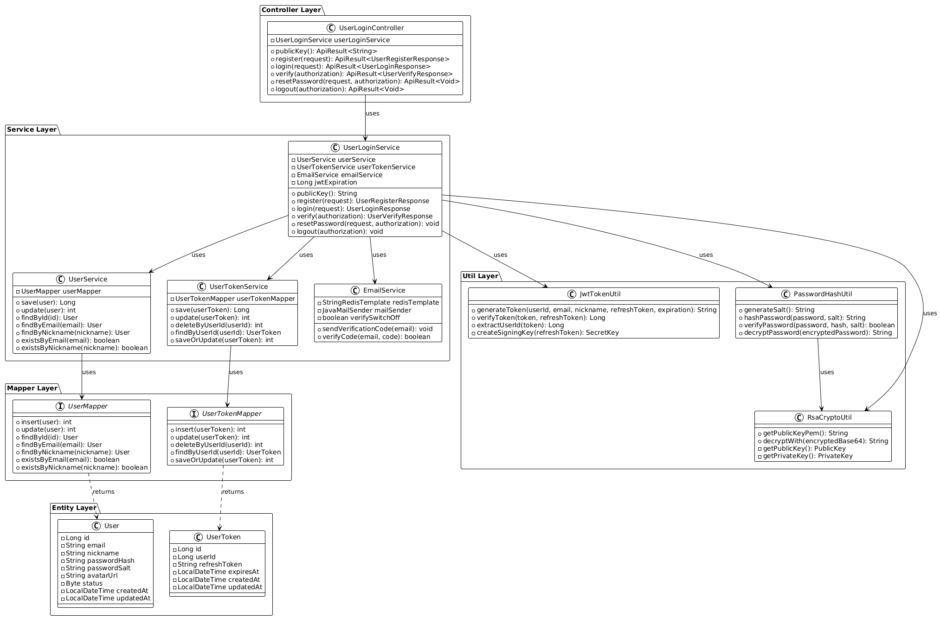

Core use case Sequence diagrams

User registration sequence diagram
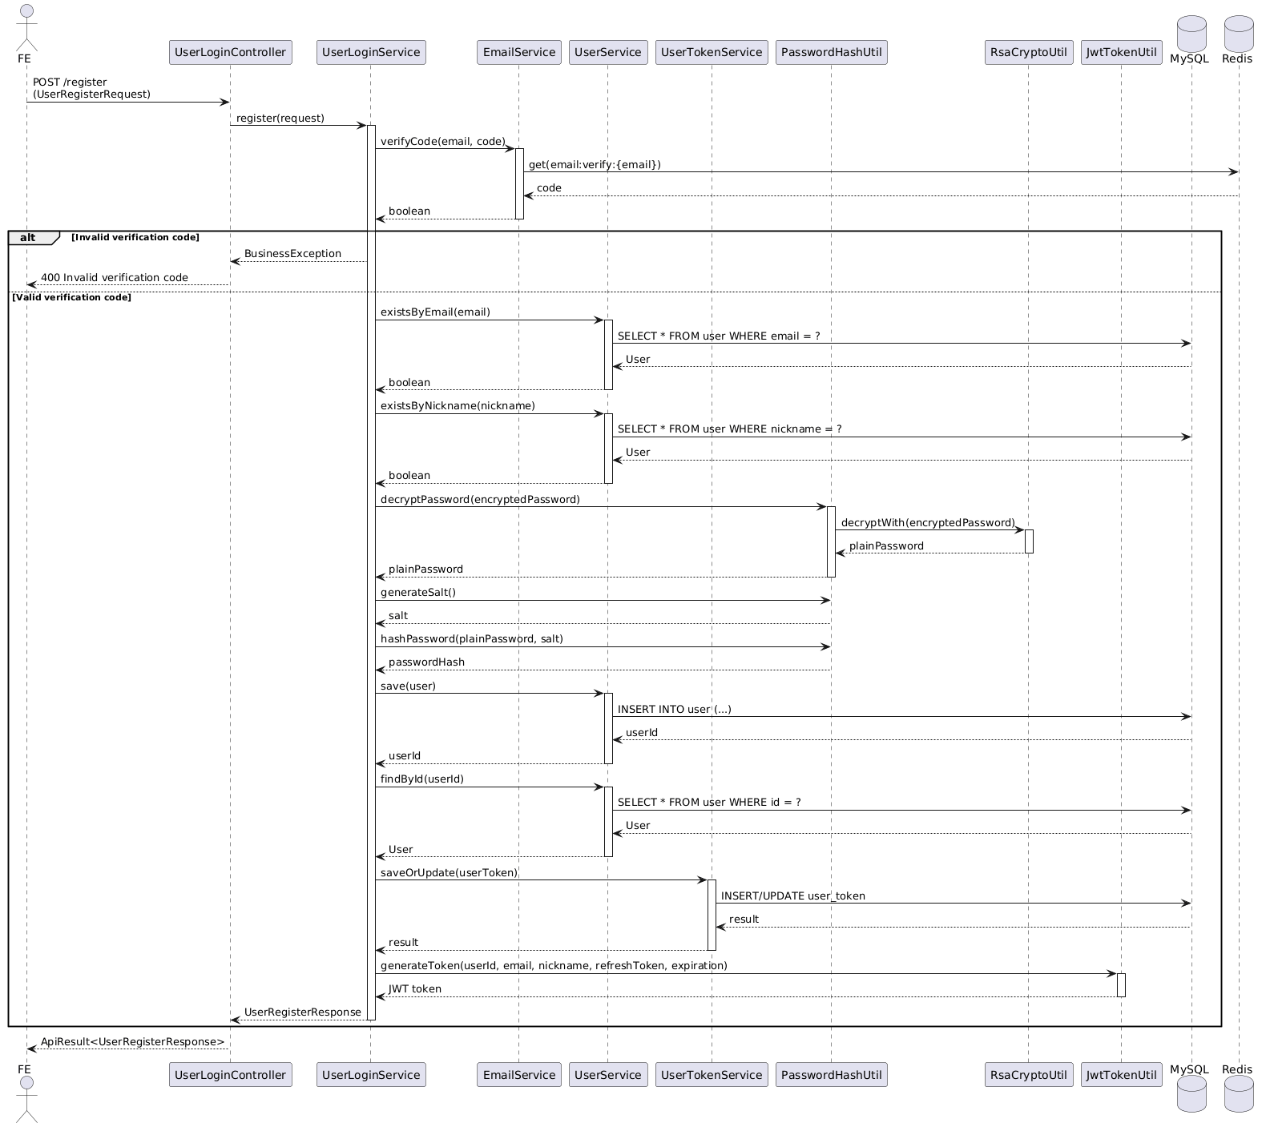

User login sequence diagram
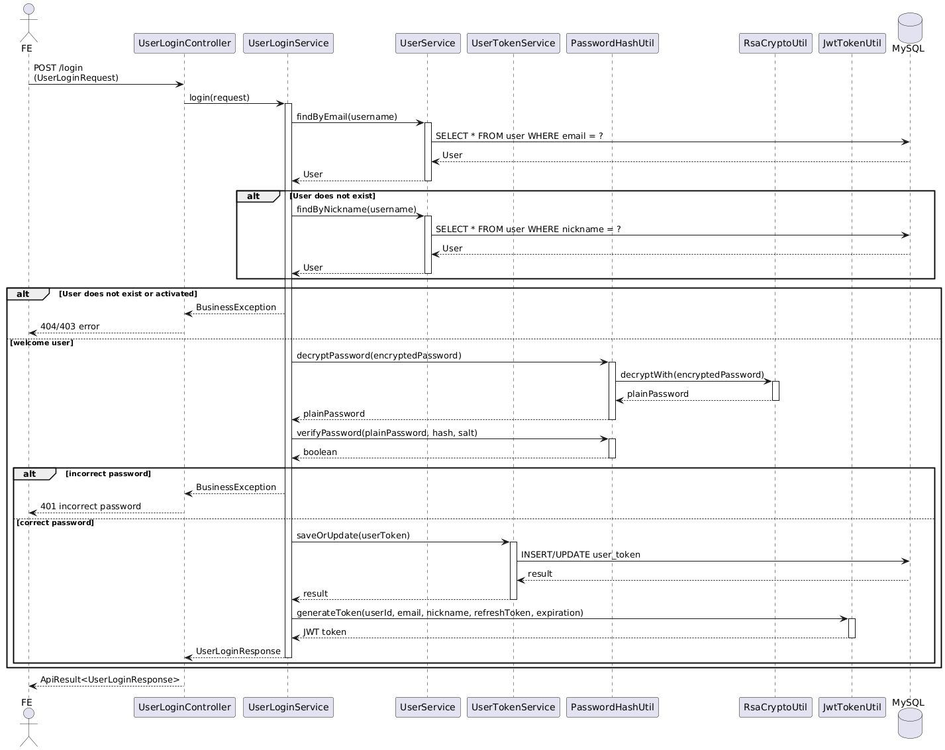

User Logout Sequence Diagram
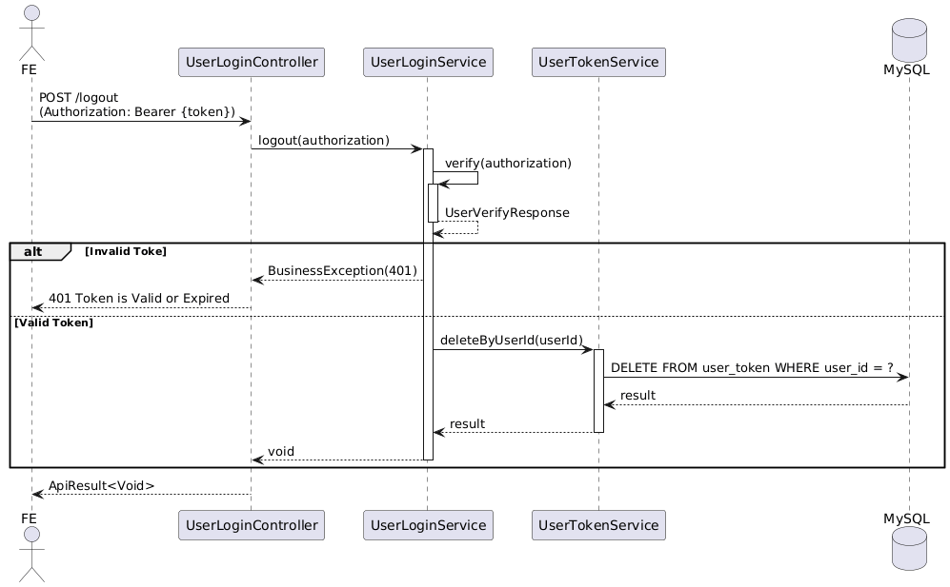

Conclusion
This project marked a turning point in my journey into software engineering. Despite the difficulties, I developed technical competence, grew mentally stronger, learned to communicate better, and truly stepped into the world of real software development. I now have clearer direction, better tools, and greater confidence to continue improving in this field as a software engineer. The challenges I encountered ultimately shaped me into a more resilient and self-directed learner.

